Name : Prashant Ranjan Roll No : 24MC3035

1) Reverse Words of File

Program 1
#include <bits/stdc++.h>
using namespace std;
int main(){
string s="Hello world this is test";
stringstream ss(s);
vector<string> v;
string w;
while(ss>>w) v.push_back(w);
for(int i=v.size()-1;i>=0;i--){
cout<<v[i];
if(i) cout<<" ";
}
}

Output
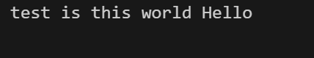

2) Split Numbers into Divisible-by-3 and Others

Program 2
#include <bits/stdc++.h>
using namespace std;
int main(){
vector<int>a={12,7,9,13,18,25,4};
vector<int>d3,oth;
for(int x:a){
if(x%3==0) d3.push_back(x);
else oth.push_back(x);
}
cout<<"Divisible by 3: ";
for(int x:d3) cout<<x<<" ";
cout<<"\nOthers: ";
for(int x:oth) cout<<x<<" ";
}

Output

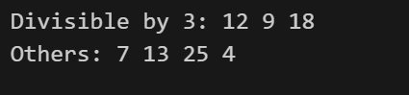

3) ASCII → Binary → ASCII

Program 3
#include <bits/stdc++.h>
using namespace std;
int main(){
vector<long long>a={10,20,30,40,50};
ofstream bin("out.bin",ios::binary);
for(long long x:a) bin.write((char*)&x,sizeof(x));
bin.close();
ifstream b("out.bin",ios::binary);
vector<long long>r;
long long x;
while(b.read((char*)&x,sizeof(x))) r.push_back(x);
cout<<"ASCII input: ";
for(long long y:a) cout<<y<<" ";
cout<<"\nRecovered from binary: ";
for(long long y:r) cout<<y<<" ";
}

Output
